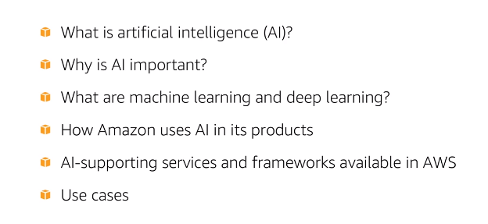

Simply stated AI is intelligent behaviour by machines. That means any device that can receive its environment and take action supported me has AI By using AI, the machine can mimic cognitive human functions like learning and problem solving A common example of using artefacts is giving machines the ability to scan and interpret their physical environment so that they can have moving around and even up and downstairs to make the machines add and reality We need to provide them with information from the real world. In order to mimic human intelligence, they have relies on something called Knowledge Engineering. Knowledge Engineering is a key component of the app research machines

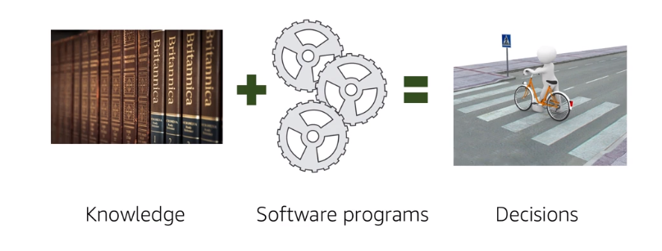

HC, AIR Technical Project to do Machines need extensive knowledge of the real world. In other words, they need to understand things like the relationships between objects and situations, the properties of an event cause,and effect and more .This processand is fed to software programmes that, in turn, analyse the data and come up with decisions for a particular problem, the way humans do.In short,the goal is trasfer human expertise to a software program , that can take upto in same data and come to same conclusion as human would .This process of feeding data to a software programme and coming up with human life decisions is also known as the modelling process. The model which is basically your software algorithm, is consistently refined until its decisions are close to those human would come up with. If the decision for a particular problem is inconsistent with what a human decision would be, then we go back to the model and debug it until we approved it. As you might expect, this is an iterative process

Ai presents us with new possibilities and promotes growth in business. All kinds of companies are using a AI to inovate

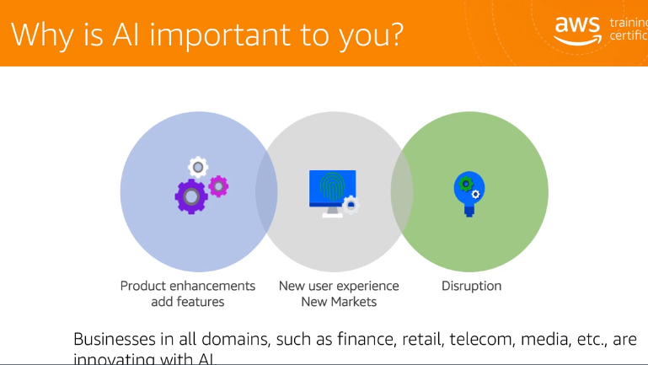

Companies are making significant investment to improve their products based on user interaction and more. And they're using AI hear a few examples of how AI is used today. Detecting your deterrent security threats and fraud, resolving users technology issues through automated call centre or chat box. Automating repeatable tasks such as payroll data and entry and audit, anticipating users actions and providing recommendations Monitoring social media comments and tailoring advertising content as per search rate .Once you start learning about ai, do you start seeing films like machine learning and deep learning? Machine learning, also called ml and deep learning, also called dl, are really subset of ai.

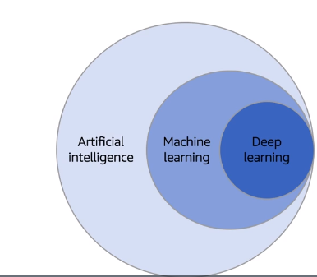

You can create an ai system with the help of ml and dl algorithms, for example. The software programme to predict user actions and success recommendations or a system that understands thoughts and sentences spoken by a human like Alexa. Let's talk about these fields and how to defer from each other.

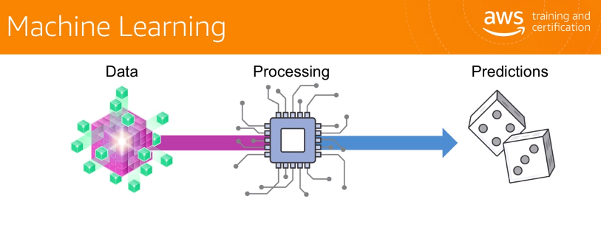

Machine learning is often deployed where explicit programming is too rigid or impractical. Unlike regular computer code, machine learning uses data to generate statistical code that will output the right result based on the pattern recognised from previous examples of input .machine learning starts with the data it already has about the situation. It processes data using algorithms to recognise patterns of a behaviour and apps dot. It then interprets those patterns to predict the future outcomes.

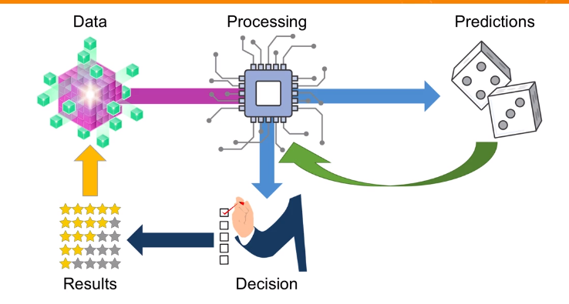

These predictions are used to make a decision about the next step for the machine learning to take. That decision produces results, which are then evaluated and added into the pole of data. The new data will influence the predictions and subsequent decisions made going forward. This is how machine learning learns overtime.

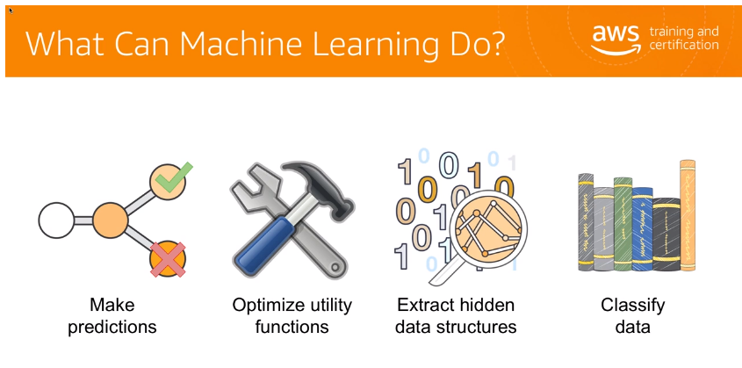

Machine learning can make predictions from huge datasets. optimise utility functions and extract hidden patterns and structures from the datasets by classifying data. This enables the software programme to learn and make predictions in the future Deep learning takes machine learning a step further, rather than telling the machine what features it needs to look for. Deep learning enables a machine to define the features it needs to look for itself based on the data is being provided

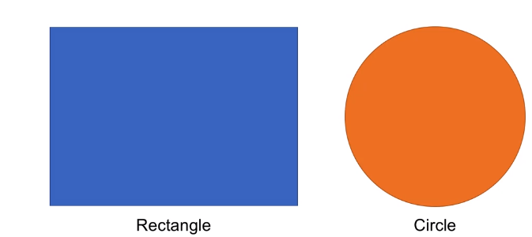

In this example, traditional machine learning requires you to tell the machine how to differentiate between a rectangle and a circle.

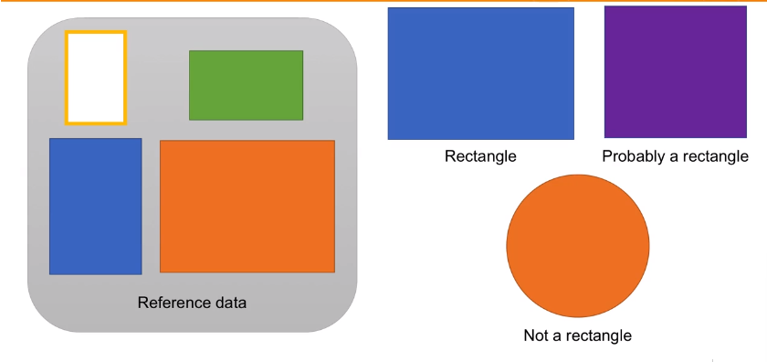

Deep learning, on the other hand, shows machines several examples of rectangles. It analyses those examples and infers common features that define a rectangle. At this point, it can identify on its own whether it's looking at a rectangle In the same way, our brains process information using neurons. Deep learning processes information using similar but artificial processing structures known as artificial neural networks.

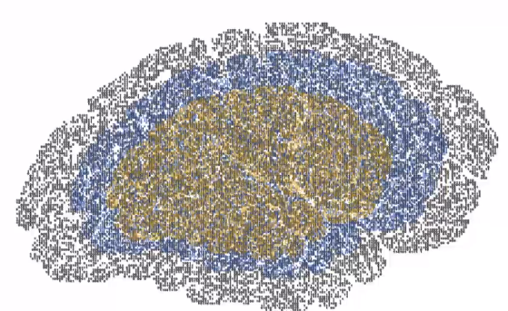

It builds these structures from the data it analyses, and then infers features about its subject matter based on the data Then it weighs those features according to certainty and commonality, and organises them into layers of hierarchies and relationships with each other To return to the circle and rectangle example, if the deep learning machine looks at its reference data on what rectangle is, it can infer that rectangles are built from 4 sides at right angles. Unlike machine learning, the deep learning machine doesn't have to be told to look for the number or angle of sides Instead, it recognises the sides as a common feature of the reference data on its own. It can then look at the big blue rectangle, see that it has four sides at right angles, and determine with strong certainty that it's a rectangle. It can also determine that the Purple Square is probably a rectangle, since it also has four sides at right angles, even though it's four sides appear to be equal, and it's not of a colour that is included in the reference data. to help understand the differences between AI, machine learning and deep learning.

Let's go through a very high level example of how these three might be applied to common task OF official recognition.

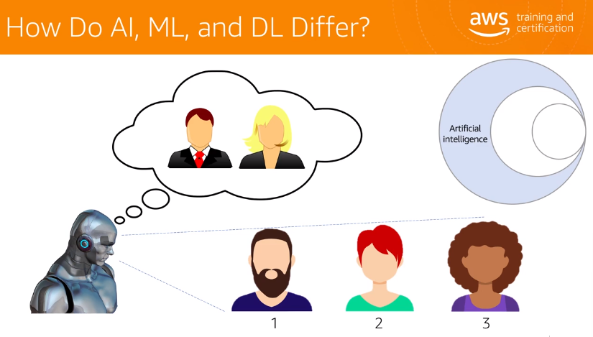

In this example, an addition intelligence would necessarily know that it was looking at three people unless it has been thought what to look for in order to spot people This requires a lot of try and error on the part of the developers creating the algorithm. And it doesn't involve the machine having to learn anything about what humans look like other than what the developers tell it to look for. The machine may be provided with the ability to identify head shapes or skin tones, but without the ability to learn, the machine could fail simply because of the wide range of diversity in what humans look like. For instance, it might not recognise a person because of a beard which could generate a false negative.

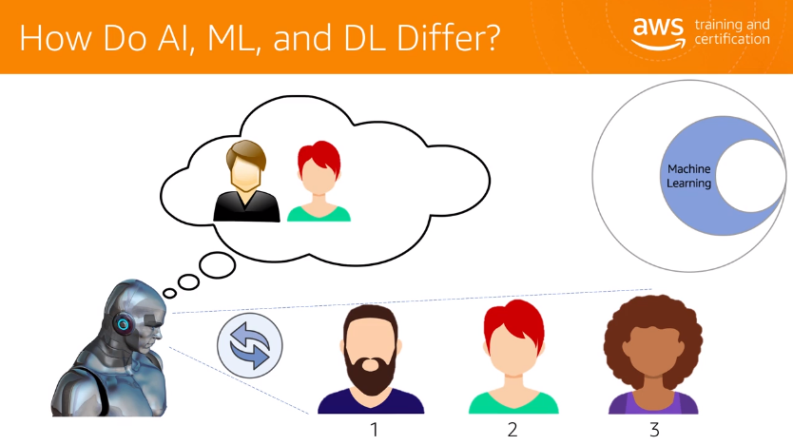

With machine learning, however, you can give the machine a rough framework for what the person looks like, and the ability to iteratively process and learn other human appearances through experience So here the machine can recognise the figure in the middle since it's the closest to the figure example, it already knows. With a similar facial shape and hair shape. Once it confirms that this new appearience is a person's face, it becomes more confident in its ability to recognise human space on facial and hair shape. But less confident in brown hair colour

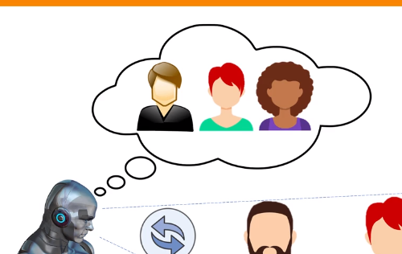

With this new information, it might now be able to recognise person 3 as its confidence and facial shape is high enough to overcome its lack of knowledge in other areas, such as hair shape and skin tone But because the machine was not prepared to recognise facial hair ahead of time, it still doesn't have the ability to recognise person 1.

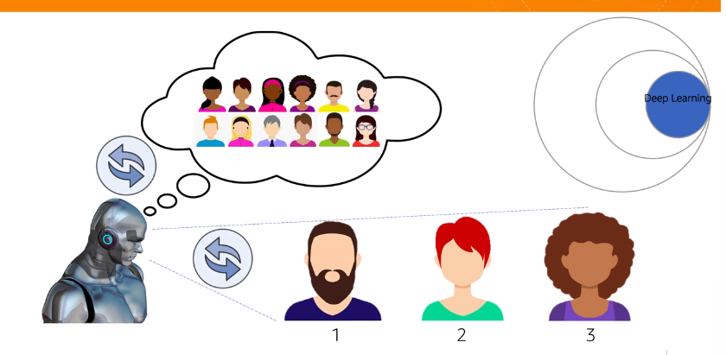

Deep learning is such a popular choice for facial recognition. With deep learning, the machine is provided lots of facial reference data up front. And unlike traditional machine learning or ai, it isn't always told exactly what features to look for. It uses its highly advanced data processing capabilities and neural networks to derive the important features it needs to look for from the data itself, rather than the developers telling the machine ahead of time how to recognise specific, hard to define things like facial hair. The machine simply looks for the common features that define all of the humans in its data and look for those In things that it sees,other words, the machine defines the essential features of the subject, rather than the developer. That's what distinguishes deep learning from the traditional machine learning. Now that we understand what AI is,

let's talk about how to establish an effective AI strategy .you can establish an effective Ai startegy in your the organisation with the help of fast computing environment. Data gathered from their sources, such as social media, browsing trends and more And advanced learning algorithms

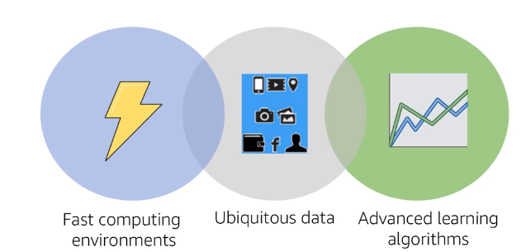

Let's start with the data More data means better analytics, and better analytics results in better products. Better products means more users And that in turn generates more data for you.

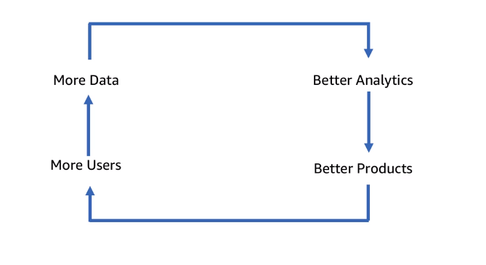

This in simple terms is the flywheel for data You can get a data from a number of sources, like click stream and user activity. Then you can analyse it using tools like do spark and Amazon search service. Using the analysis, you can feed the ai and machine learning algorithms to form pattern recognitions and generate predictions.

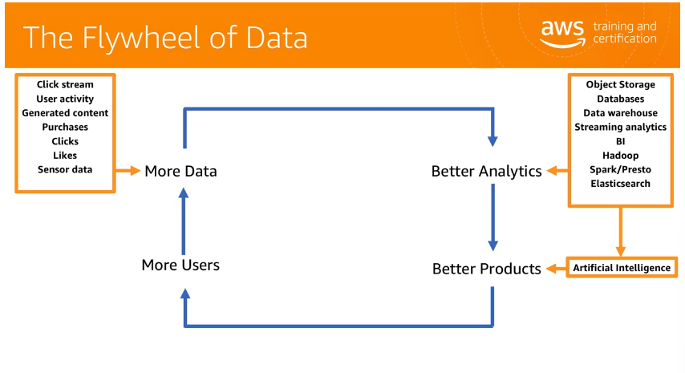

Then you can use those predictions to make your products better and drive more users to it ByUsing a combination of programming models, algorithms, data and hardware acceleration with infrastructure such as GPU. You can develop a framework that helps with AI enable features like image understanding, speech recognition, natural language processing and economy. This combination of programming models algorithms and data is usually what forms the basis of machine learning and deep learning framework. And the underlying hardware infrastructure supports the frameworks .

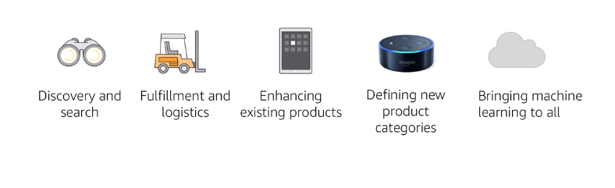

today Ai is being used all across Amazon. On Amazon.com users see recommendations suggested by Amazon's recommendation engine, which includes their shopping experience. We also use ai to spot trends in the customers experience so that we can develop new products and enhance existing products in the fulfilment and logistic departments. Robots pick pile sort and move boxes around so that they can be shipped to customers. Our employees used to have to work mouse each day by using ai. We save time and free of our staff to serve more customers faster And now it'll be us is making ai tools broadly available so that businesses can innovate and improve their products

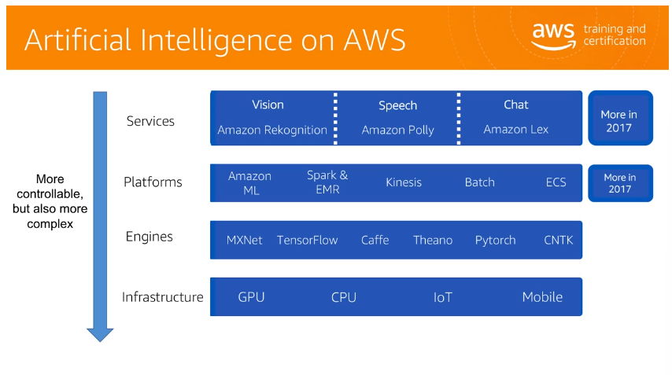

Amazon Web Services offers a range of services in ai by leveraging Amazon's internal experience with ai and machine learning. These services are separated here according to four layers, ai services, ai platforms, ai frameworks and ai infrastructure. They organise from the least complex to the most complex going from top to bottom Let's take a brief look into each of these layers. Our ai services are buit to handle specific common ai tasks. These services enable developers to add intelligence to their applications through an api called pretrained services, rather than developing and training their own deep learning models. Amazon recognition makes easy to add image analysis to your application. With recognition, you can detect specific objects, scenes and faces, like celebrities, and identify inappropriate content and Images. You can also search and compare faces. Recognition api enables you to quickly add sophisticated, deep learning based visual search and image classification to your application. Amazon Polly is a service that turns text into lifelike speech, allowing you to create applications that talk and build entirely new categories of speech enabled products. Amazon Polly, text to speech service uses advanced deep learning technologies to synthesise speech that sounds like human voice .Amazon Lex Service for building conversational interfaces into any application using voice and text. It provides automatic speech recognition for converting speech to text and natural language understanding to recognise the intent of the text. That lets you build applications with highly engaging user experiences and lifelike conversational interactions The ai platforms layer of the stack includes products and frameworks that are designed to support custom ai related tasks, such as training of machine learning model with your own data For customers who want to fully manage platform for building models using their own data, we have Amazon machine learning. It's designed for developers and data scientists who want to focus on building models. The platform removes the undifferentiated overhead associated with deploying and managing infrastructure for training and hosting models ,it can analyse your data, provide you with suggested transformation for the data. Train your model and even help you with evaluating your model for accuracy. Amazon EMR is a flexible, customizable and manage big data processing platform. It's a managed solution in that it can handle things like scaling and higher availability. Amazon emr does not require that deep understanding of how to set up an administer big data platform You get a pre configured cluster ready to receive your analytics workload. It is built for any data science workload, not just AI. Apache spark is an open source, distributed processing system commonly used for big data workloads. Apache spark utilises in memory caching and optimise execution for fast performance

Performance and supports general match processing, swimming anylatics?, machine learning graph database ?and ADD HUB QUERIES?. It can be run and manage on Amazon ai marclusters?. The AI framework in infrastructure layers are for expert machine learning practitioners. In other words, for the people who are comfortable building deeply models, training them, doing predictions also known as inference, and getting the data from the modules into production applications The online infrastructure consists of Amazon ecc 3 incenses, which are optimises for machine learning and deep learning Amazon ec 2E3 instances provide powerful Nvidia gpu's to accelerate computations so that customers can train their models in a fraction of the time required by traditional CPU. After training, Amazon EC 2 C-5 compute optimise and M4 general purpose instances. In addition to gpu based incessors, our world features for running inferences with Supports all the major deep learning frameworks and makes them easy to deploy without aws deep learning Amazon Machine Image, which is available for Amazon Linux and Ubuntu, so that you can create managed, automatically scalable clusters of gpus for training at inference at any scale. Become preinstalled with technologies like Apache and xnet cancer flow cafe and cafe 2 and other popular machine learning software such as the Anaconda package for data science

Now let's go through a few cases Almost all industry domains are now innovating with AWSAI for example, frontal net uses Amazon machine learning to support its machine learning models. The company uses Amazon Dynamo tp and iaws landlord to run code without provisioning and managing servers. Further net offer uses Amazon Red Shield for data analysis. What are the benefits that they get from that setup? Front of net launches and trains machine learning models in almost half the time it took on other platforms. It reduces complexity and makes sense of emerging fraud patterns It saves customers about $1,000,000 each week To summarise, you can create an impact in your business by automating repetitive and manual tasks engaging customers and optimising product quality using ai. I hope you learn a lot something and will continue to explore other courses.

